Tequila Cocktails

* • 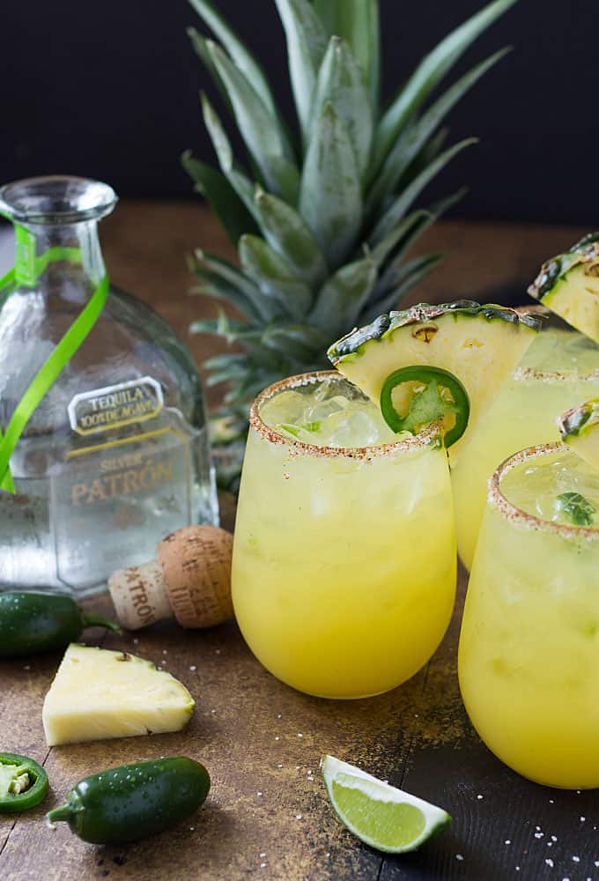

Ingredients

~5 jalapeño slices

~5 mint leaves

1/2 Tbsp lime juice

•1/2 cup pineapple juice

* •1 Tbsp maple syrup
* •1.5 oz Casamigos tequila
* •handful of ice
* Trader Joe’s chili lime seasoning
* 1 lime wedge
* Lime flavored bubly sparkling water

✨how to:

Muddle jalapeño slices, mint, and lime juice in a cocktail shaker.

Add in pineapple juice, maple syrup, tequila, and ice and shake.

Place chili lime seasoning on a plate. Rim a glass with a lime wedge and dip into seasoning to coat.

Strain margarita into rimmed glass and top with sparkling water (optional).

Enjoy :) 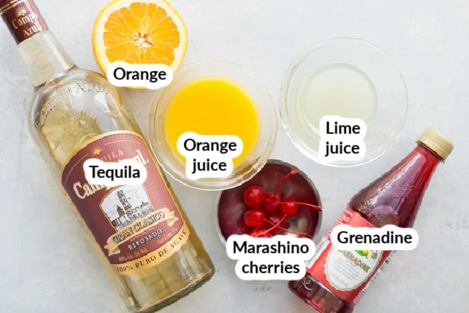

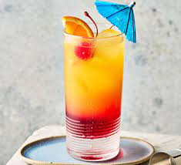

Tequila Sunrise

* 2 ounces blanco tequila
* 4 ounces orange juice, freshly squeezed
* 1/4 ounce [grenadine](https://www.liquor.com/grenadine-recipe-5071284)
* Garnish: orange slice
* Garnish: cherry

1. Add the tequila and then the orange juice to a chilled highball glass filled with ice.
2. Top with the grenadine, which will sink to the bottom of the glass, creating a layered effect.
3. Garnish with an orange slice and a cherry.